**CHAPTER 1**

**ABSTRACT**

In this project we are generating electrical power as non-conventional method by simply running on the vehicle. The power is generated by the rack and pinion arrangement is fitted in the vehicle shock absorber. Non-conventional energy system is very essential at this time to our nation. Non-conventional energy using shock absorber needs no fuel input power to generate the output of the electrical power. This project using simple drive mechanism such as rock and pinion assemble and chain drive mechanism.

**CHAPTER 2**

**INTRODUCTION**

Fossil fuels are being consumed with very fast rate. Also the cost of fuel is increasing with a very fast rate. So somebody has to work on saving of the fuel consumption. Our aim is to demonstrate how the kinetic energy from the suspension of a car can be utilized to achieve our goal of obtaining maximum energy that would otherwise have gone waste.

The vehicle manufacturers have made costly strides to improve fuel economy. Car designers also spend great deal of effort to reduce wind drag so as to improve fuel economy through streamlined low drag vehicle body design. Manufacturers also use lighter material to reduce the weight of vehicle and ultimately to reduce fuel consumption. It is well known that automobiles are inefficient, wasting over 74% of energy stored in fuel as a heat. Major energy losses are engine losses (62.5%), idle & standby (17.2%), braking losses (5.8%), rolling resistance (4.2%) & drive line losses (5.2%), accessory usage (2.5%), aerodynamic drag (2.6%). To recover energy from 5.8 % braking losses, regenerative braking systems are developed and successfully implemented in electric vehicles.In addition to thermal efficiency and braking energy, oneimportant loss is kinetic energy dissipated by shock absorbers.

This energy recovery mechanism that is still in the research stages is Regenerative suspension systems. This technology has the ability to continuously recover a vehicle's vibrational energy dissipation that occurs due to road irregularities, vehicle acceleration, and braking, and use the energy to reduce fuel consumption. The function of vehicle suspension system is to supportthe weight of vehicle body, to isolate the vehicle chassis from road disturbances, and to enable the wheels to hold theroad surface. Two chief elements in suspension are spring and damper. Conventionally, damper is designed to dissipatevibration energy into heat to attenuate the vibration which is transmitted from road excitation. However, the dissipatedheat is energy is wasted.

Therefore, we propose a design plan that converts the mechanical energy in cars to electrical energy much more efficiently than before. The electricity generated will then be used to recharge the car battery. Although the reciprocating distance is very low the suspending mass is very high i.e. the mass of total vehicle. When vehicle is on a normal road then also shock absorbers are working due to uneven roads, sudden breaking or sudden acceleration. So this reciprocating motion of shock absorbers can be converted into rotary motion from which electricity is generated through

**LITERATURE REVIEW**

Meghraj P.Arekar , Swapnil Shahade

Power Generating Shock Absorber

An electromagnetic linear generator and regenerative electromagnetic shock absorber is disclosed which converts variable frequency, repetitive intermittent linear displacement motion to useful electrical power. The innovative device provides for superposition of radial components of the magnetic flux density within a coil winding array. Due to the vector superposition of the magnetic field and magnetic flux from a plurality of magnets, a nearly four-fold increase in magnetic flux density is achieved over conventional electromagnetic generator designs with a potential sixteen-fold increase in power generating capacity. As a regenerative shock absorber, the disclose device is capable of converting parasitic displacement motion and vibration encountered under normal urban driving condition to a useful electrical energy for powering vehicles and accessories or charging batteries in electric and fossil fuel powered vehicles. The disclosed device is capable of high power generation capacity and energy conversion efficiency with minimal weight penalty for improved fuel efficiency.

Himanshu S. Rewatkar , Vicky R. Gedekar , Kunal L. Parate

Power Generation by Using Suspension System

The main objective of designed the controller for a vehicle suspension system is to reduce the discomfort sensed by passengers which arises from road roughness and to increase the ride handling associated with the pitching and rolling movements. This necessitates a very fast and accurate controller to meet as much control objectives, as possible.

Therefore, this paper deals with an artificial intelligence Neuro-Fuzzy (NF) technique to design a robust controller to meet the control objectives. The advantage of this controller is that it can handle the nonlinearities faster than other conventional controllers.

The approach of the proposed controller is to minimize the vibrations on each corner of vehicle by supplying control forces to suspension system when travelling on rough road. The other purpose for using the NF controller for vehicle model is to reduce the body inclinations that are made during intensive manoeuvres including braking and cornering.

A full vehicle nonlinear active suspension system is introduced and tested. The results show that the intelligent NF controller has improved the dynamic response measured by decreasing the cost function.

Sunny Wagh , Amol Thombare , Prashant Kanhurkar , Dhanaji Shelake, Swapnil Pawar

Power Generating Magnetic Shock Absorber

The function of vehicle suspension system is to support the weight of vehicle body, to isolate the vehicle chassis from road disturbances, and to enable the wheels to hold the road surface.

A magnetic shock absorber which makes use of the magnetic repulsion between dipoles to achieve shock absorption, the suspension system consists of magnets freely moving inside the cylinder with their same poles facing each other. Since the magnetic poles repel each other while moving closer, the up and down spring action is obtained.

This shock absorber will eradicate the problems faced in the spring shock absorbers due to friction and other factors. This will also reduce the maintenance costs as it does not need repairing, changing of springs or dealing with leakage problems as in spring or oil shock absorbers.

This magnetic shock absorber can be used in vehicles carrying heavy or less load. Presented in this paper the method aimed at determining the effectiveness of efficiently transforming suspension energy into electrical power by using regenerative magnetic shock absorbers.

In turn, the electrical power can be used to recharge batteries or other efficient energy storage devices rather than be dissipated.

Kadam Amit R Satpute Vaibhav D Shinde Abhishek

Electricity Generation By Using Shock Absorber

For smooth and comfortable ride the disturbing forces should be eliminated. In conventional system we are attaching the shaft of dynamo (permanent magnet DC generator) to the engine to charge the battery.

In this project/paper we are going to highlight a new method by using which we can eliminate the shocks as well as improve the overall efficiency of vehicle.

Conventional shock absorbers simply dissipate this energy as heat. In our project, we are going to harvest this waste energy to charge the battery of vehicle.

This can be done by using two methods, either by redesigning the shock absorber which will accommodate various parts of harvesting system or by simply using rack, pinion arrangement attached to shock absorber.

Out of these two we are using the second method. As shock absorber effect formed, spring is compressed and linear movement of rack is converted in rotary motion due to pinion moves as the rack is meshed with pinion.

And the pinion is mounted on the shaft which is connected to shaft of dynamo. Due to this arrangement, rotary motion of pinion is used to rotate dynamo. As dynamo rotation leads to generation of energy.

And this energy is energy is used to charge the battery and this stored energy is used for different vehicle accessories like power window, lights and air conditioner etc.

This energy is applicable in most of the military vehicles, race automobile and maximum suspension system

**SCOPE AND OBJECTIVE**

As of my last knowledge update in January 2022, there haven't been widespread applications or developments in shock absorber power generation.

However, if there have been advancements since then, I'll provide a general overview of the potential scope and objectives based on the existing concepts up to that point.

Shock absorber power generation refers to the utilization of the mechanical energy generated by the motion of a vehicle's suspension system, specifically the shocks or dampers, to produce electrical power.

It's important to note that the practical implementation and widespread adoption of shock absorber power generation may be influenced by technological, economic, and regulatory factors.

Advancements in materials, engineering design, and energy conversion technologies will play a crucial role in realizing the full potential of shock absorber power generation.

**CHAPTER 3**

**WORKING PRINCIPLE**

In this project we have to develop a suspension energy generation unit by using rack and pinion method. It is less costly than the hydraulic unit.

Part of the system:

1. Suspension unit
2. Rack and pinion
3. Generator
4. LED Light
5. Base for the setup

Here, when the suspension works, the rack is set moving in a reciprocating motion. Due to this, the pinion starts rotating. The rotation ofthe pinion is then transferred to the generator which generates the electricity.

**CHAPTER 4**

**LIST OF MATERIALS**

1. FRAME
2. SHAFT
3. BEARING
4. RACK AND PINION
5. DYNAMO
6. SHOCK ABSORBER

**SHAFT**

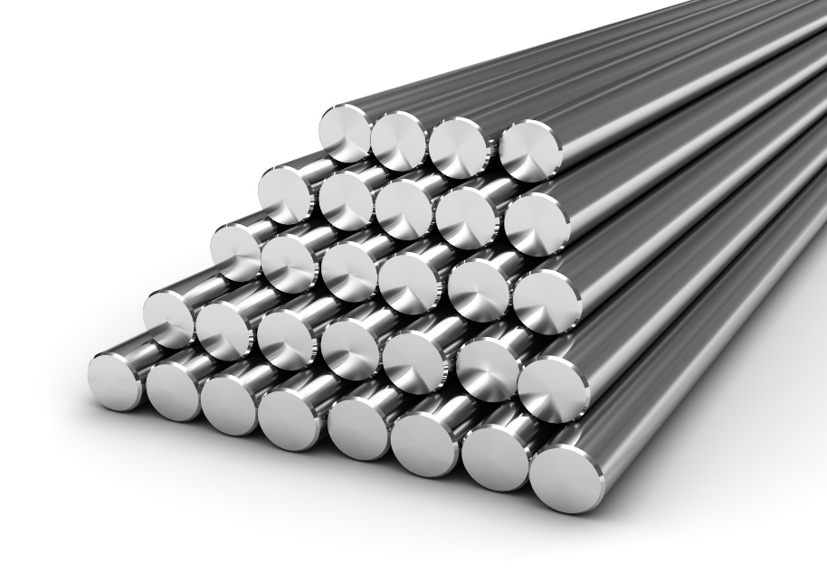

**Specifications**

Shaft diameter: 12mm

Material: mild steel

Length:26 inch

**SHAFT**

Shaft is a common and important machine element. It is a rotating member, in general, has a circular cross-section and is used to transmit power. The shaft may be hollow or solid. The shaft is supported on bearings and it rotates a set of gears or pulleys for the purpose of power transmission. The shaft is generally acted upon by bending moment, torsion and axial force. Design of shaft primarily involves in determining stresses at critical point in the shaft that is arising due to aforementioned loading. Other two similar forms of a shaft are axle and spindle. Axle is a non-rotating member used for supporting rotating wheels etc. and do not transmit any torque.

Spindle is simply defined as a short shaft. However, design method remains the same for axle and spindle as that for a shaft. 8.1.2 Standard sizes of Shafts Typical sizes of solid shaft that are available in the market are, Up to 25 mm 0.5 mm increments 25 to 50 mm 1.0 mm increments 50 to 100 mm 2.0 mm increments 100 to 200 mm 5.0 mm increments 8.1.3 Material for Shafts The ferrous, non-ferrous materials and non metals are used as shaft material depending on the application. Some of the common ferrous materials used for shaft are discussed below. Hot-rolled plain carbon steel.

These materials are least expensive. Since it is hot rolled, scaling is always present on the surface and machining is required to make the surface smooth.Since it is cold drawn it has got its inherent characteristics of smooth bright finish. Amount of machining therefore is minimal. Better yield strength is also obtained. This is widely used for general purpose transmission shaft.

**BALL BEARING**

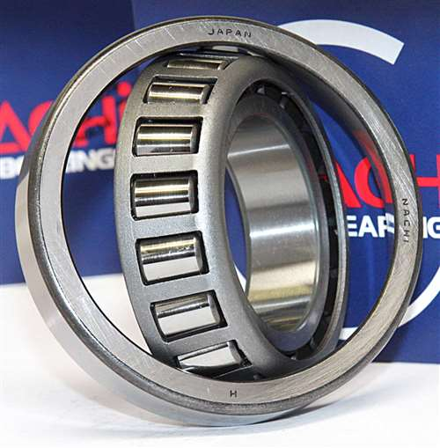

A ball bearing is a type of [rolling-element bearing](https://en.wikipedia.org/wiki/Rolling-element_bearing) that uses [balls](https://en.wikipedia.org/wiki/Ball_(bearing)) to maintain the separation between the [bearing](https://en.wikipedia.org/wiki/Bearing_(mechanical)) [races](https://en.wikipedia.org/wiki/Race_(bearing)).

The purpose of a ball bearing is to reduce rotational friction and support [radial](https://en.wikipedia.org/wiki/Radius) and [axial](https://en.wikipedia.org/wiki/Axis_of_rotation) loads. It achieves this by using at least three races to contain the balls and transmit the loads through the balls. In most applications, one race is stationary and the other is attached to the rotating assembly (e.g., a hub or shaft). As one of the bearing races rotates it causes the balls to rotate as well. Because the balls are rolling they have a much lower [coefficient of friction](https://en.wikipedia.org/wiki/Coefficient_of_friction) than if two flat surfaces were sliding against each other.

Ball bearings tend to have lower [load capacity](https://en.wikipedia.org/wiki/Structural_load) for their size than other kinds of rolling-element bearings due to the smaller contact area between the balls and races. However, they can tolerate some misalignment of the inner and outer races.

**SPECIFICATION**

INNER DIA :12mm

OUTER DIA : 37mm

**DC GENERATOR**

A dc generator is an electrical machine which converts mechanical energy into direct current electricity. This energy conversion is based on the principle of production of dynamically induced emf.

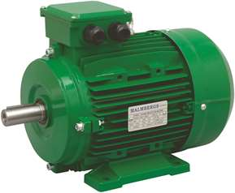

Although a far greater percentage of the electrical machines in service are a.c. machines, the d.c. machines are of considerable industrial importance. The principal advantage of the d.c machine, particularly the d.c. motor, is that it provides a fine control of speed. Such an advantage is not claimed by any a.c. motor. However, d.c. generators are not as common as they used to be, because direct current, when required, is mainly obtained from an a.c. supply by the use of rectifiers. Nevertheless, an understanding of d.c. generator is important because it represents a logical introduction to the behavior of d.c. motors. Indeed many d.c. motors in industry actually operate as d.c. generators for a brief period. In this chapter, we shall deal with various aspects of d.c. generators.

**SPECIFICATION**

Number of poles: 6

Speed in rpm:1440rpm

**GENERATOR PRINCIPLE**

An electric generator is a machine that converts mechanical energy into electrical energy. An electric generator is based on the principle that whenever flux is cut by a conductor, an e.m.f. is induced which will cause a current to flow if the conductor circuit is closed. The direction of induced e.m.f. (and hence current) is given by Fleming’s right hand rule. Therefore, the essential components of a generator are:

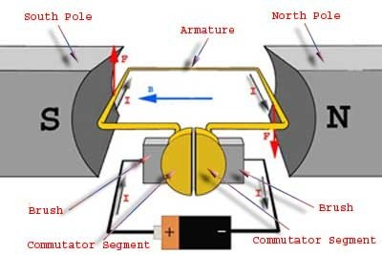

(a) a magnetic field

(b) Conductor or a group of conductors

(c) Motion of conductor w.r.t. magnetic field.

**RACK AND PINION**

Rack and pinion animations rack and pinion is a type of linear actuator that comprises a pair of gears which convert rotational motion into linear motion. The circular pinion engages teeth on a linear “gear” bar–the rack. Rotational motion applied to the pinion will cause the rack to move to the side, up to the limit of its travel. For example, in a rack railway, the rotation of a pinion mounted on a locomotive or a rail car engages a rack between the rails and pulls a train along a steep slope.

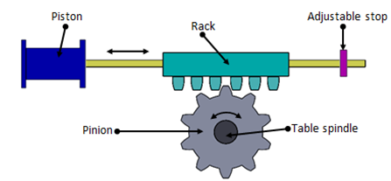

* A rack is a gear whose pitch diameter is infinite, resulting in a straight line pitch circle.
* Involute of a very large base circle approaches a straight line.
* Used to convert rotary motion to straight line motion.
* Used in machine tools.

**SPECIFICATION**

Material : cast-iron

Outside diameter : 76mm

Circular pitch : 4.9mm

Tooth depth : 3.385mm

Module : 1.7mm

Pressure angle : 21°

Pitch circle diameter : 77mm

Addendum : 1.5mm

Dedendum : 1.875mm

Circular tooth Thickness : 2.365mm

Fillet radius : 0.46mm

Clearance : 0.385mm

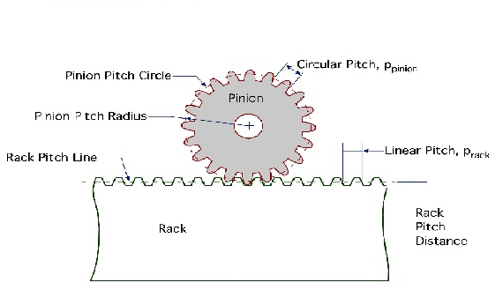

A rack and pinion is a type of linear actuator that comprises a pair of gears which convert rotational motion into linear motion. A circular gear called “the pinion” engages teeth on a linear “gear” bar called “the rack”; rotational motion applied to the pinion causes the rack to move, thereby translating the rotational motion of the pinion into the linear motion of the rack.

**PINION**

Pinion With high precision and load-bearing capacity as well as smooth running properties, the pinions from WMH Herion are extremely reliable power transmitters even during continuous operation.

**RACK**

Rack Precision-ground racks from WMH Herion allow the rotary movement of the pinion to be transformed exactly into a linear movement.

When we say “on request” we mean: everything is possible. You benefit from the flexibility of two specialist companies with development skills and a range of components that is quite unique in the world. We do everything in our power to ensure you get just the rack and pinion drive you require. From customising through more minor application-specific adaptation of our range components through adaptation of design sizes to the development of tailor-made solutions. Working with you, we design the optimum and most economic customised solution which is in no way inferior to our tried-and trusted series products in terms of either quality or efficiency.

In practice, keyway connections have proved themselves economical and are convincing thanks to their simple fitting/removal. In addition, the precise and central seat of the hub is an advantage.

SHOCK ABSORBER

A shock absorber or damper is a mechanical device designed to smooth out or damp shock impulse, and dissipate kinetic energy.A shock absorber is basically a hydraulic amping mechanism for controlling spring vibrations. It controls spring movements in both directions, whenthe spring is compressed and when it isextended, the amount of resistance needed in each direction is determined by the type of vehicle, the type of suspension, the location of the shock absorber in the suspension system and the position in which it is mounted. Shock absorber supercritical product that determines an automobile’s character not only by improving ride quality but a lobby functioning to control theattitudeandstabilityoftheautomobilebody.

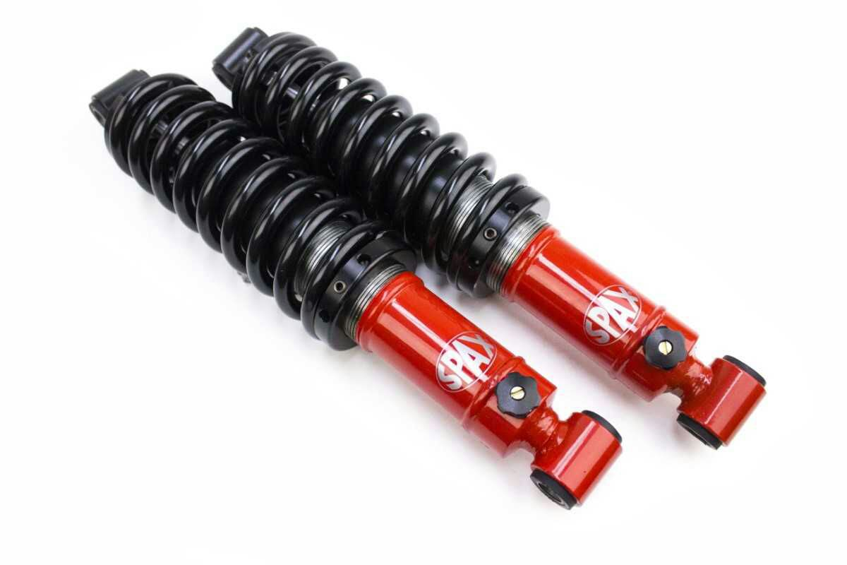

**Shock Absorber**

The shock absorbers duty is to absorb or dissipate energy. One design consideration, when designing or choosing a shock absorber, is where that energy will go. In most dashpots, energy is converted to heat inside the viscous fluid. In hydraulic cylinders, the hydraulic fluid will heat up, while in air cylinders, the hot air is usually exhausted to the atmosphere. In other types of dashpots, such as electromagnetic ones, the dissipated energy can be stored and used later. In general terms, shock absorbers help cushion cars on uneven roads.

**VEHICLE SUSPENSION**

In a vehicle, it reduces the effect of traveling over rough ground, leading to improved ride quality, and increase in comfort due to substantially reduced amplitude of disturbances. Without shock absorbers, the vehicle would have a bouncing ride, as energy is stored in the spring and then released to the vehicle, possibly exceeding the allowed range of suspension movement.

Control of excessive suspension movement without shock absorption requires stiffer (higher rate) springs, which would in turn give a harsh ride. Shock absorbers allow the use of soft (lower rate) springs while controlling the rate of suspension movement in response to bumps.

They also, along with hysteresis in the tire itself, damp the motion of the unspring weight up and down on the springiness of the tire. Since the tire is not as soft as the springs, effective wheel bounce damping may require stiffer shocks than would be ideal for the vehicle motion alone.



**Vehicle Suspension**

Spring-based shock absorbers commonly use coil springs or leaf springs, though torsion bars can be used in tensional shocks as well. Ideal springs alone, however, are not shock absorbers as springs only store and do not dissipate or absorb energy.

Vehicles typically employ springs and torsion bars as well as hydraulic shock absorbers. In this combination, "shock absorber" is reserved specifically for the hydraulic piston that absorbs and dissipates vibration

**METAL FRAME**

The metal frame is generally made of **mild steel** bars for machining, suitable for lightly stressed components including studs, bolts, gears and shafts. It can be case-hardened to improve wear resistance. They are available in bright rounds, squares and flats, and hot rolled rounds

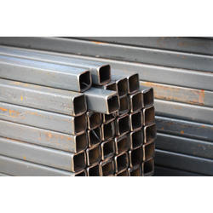

Suitable machining allowances should therefore be added when ordering. It does not contain any additions for enhancing mechanical or machining properties. Bright drawn mild steel is an improved quality material, free of scale, and has been cold worked (drawn or rolled) to size. It is produced to close dimensional tolerances. Straightness and flatness are better than black steel.

**CHAPTER 5**

**MATERIAL USED**

|  |  |  |  |
| --- | --- | --- | --- |
| S.No | DESCIRPTION | QTY | MATERIAL |
| 1 | FRAME | 1 | MILD STEEL |
| 2 | SHAFT | 1 | MILD STEEL |
| 3 | BEARING | 3 | STAINLESS STEEL |
| 4 | DYNAMO | 1 | ELECTRICAL |
| 5 | RACK AND PINION | 1 | MILD STEEL |
| 6 | SHOCK ABSORBER | 1 | MILD STEEL |

**MANUFACTURING PROCESS**

Manufacturing processes are the steps through which raw materials are transformed into a final product. The manufacturing process begins with the creation of the materials from which the design is made. These materials are then modified through manufacturing processes to become the required part. Manufacturing processes can include treating (such as heat treating or coating), machining, or reshaping the material. The manufacturing process also includes tests and checks for quality assurance during or after the manufacturing, and planning the production process prior to manufacturing.

**SAWING:**

Cold saws are saws that make use of a circular saw blade to cut through various types of metal, including sheet metal. The name of the saw has to do with the action that takes place during the cutting process, which manages to keep both the metal and the blade from becoming too hot. A cold saw is powered with electricity and is usually a stationary type of saw machine rather than a portable type of saw.

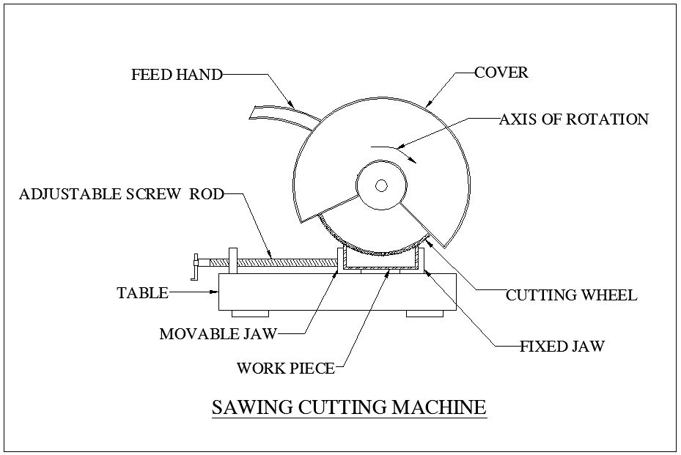

The circular saw blades used with a cold saw are often constructed of high speed steel. Steel blades of this type are resistant to wear even under daily usage. The end result is that it is possible to complete a number of cutting projects before there is a need to replace the blade.High speed steel blades are especially useful when the saws are used for cutting through thicker sections of metal.

**WELDING:**

Welding is a process for joining similar metals. Welding joins metals by melting and fusing **1,** the base metals being joined and **2,** the filler metal applied. Welding employs pinpointed, localized heat input. Most welding involves ferrous-based metals such as steel and stainless steel.Weld joints are usually stronger than or as strong as the base metals being joined.

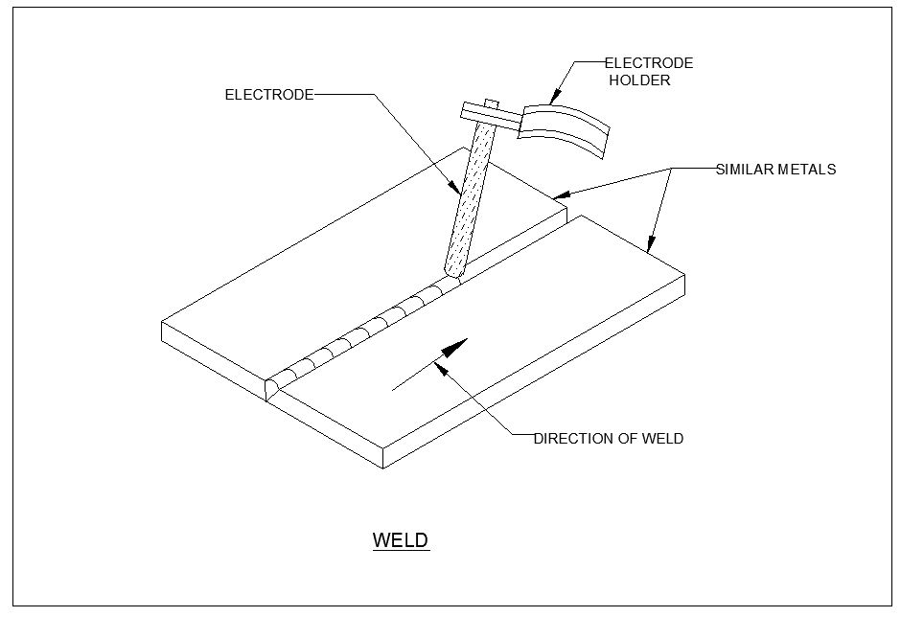

Welding is used for making permanent joints. It is used in the manufacture of automobile bodies, aircraft frames, railway wagons, machine frames, structural works, tanks, furniture, boilers, general repair work and ship building.

**OPERATION:**

Several welding processes are based on heating with an electric arc, only a few are considered here, starting with the oldest, simple arc welding, also known as shielded metal arc welding (SMAW) or stick welding.

In this process an electrical machine (which may be DC or AC, but nowadays is usually AC) supplies current to an electrode holder which carries an electrode which is normally coated with a mixture of chemicals or flux. An earth cable connects the work piece to the welding machine to provide a return path for the current. The weld is initiated by tapping ('striking') the tip of the electrode against the work piece which initiates an electric arc. The high temperature generated (about 6000oC) almost instantly produces a molten pool and the end of the electrode continuously melts into this pool and forms the joint.

**DRILLNG:**

Drilling is a cutting process that uses a drill bit to cut or enlarge a hole of circular cross-section in solid materials. The drill bit is a rotary cutting tool, often multipoint. The bit is pressed against the work piece and rotated at rates from hundreds to thousands of revolutions per minute. This forces the cutting edge against the work piece, cutting off chips (sward) from the hole as it is drilled

**CHAPTER 6**

**ADVANTAGES AND APPLICATIONS**

**ADVANTAGES**

* The project is economical and easy to install.
* This project is non polluting.
* Maintenance cost is low.
* Installation cost is low.

**APPLICATION**

* Applications such as battery charger.
* All two wheeler applications
* Automobile industry

**COST ESTIMATION**

|  |  |  |
| --- | --- | --- |
| **SL.NO** | **DISCRIPTION** | **COST Rs:** |
| 1 | FRAME | 700 |
| 2 | SHAFT | 750 |
| 3 | BEARING | 600 |
| 4 | DYNAMO | 1150 |
| 5 | RACK AND PINION | 600 |
| 6 | SHOCK ABSORBER | 700 |
| 7 | TOTAL | 4500 |

**LABOUR COST**

LATHE, DRILLING, WELDING, GRINDING, POWER HACKSAW, GAS CUTTING:

Cost = 500/-

**TOTAL COST**

Total cost = Material Cost + Labour cost

= Rs 4500 + 500

Total cost for this project = Rs.5000

**CHAPTER 7**

**3D LAYOUTS OF MODEL**

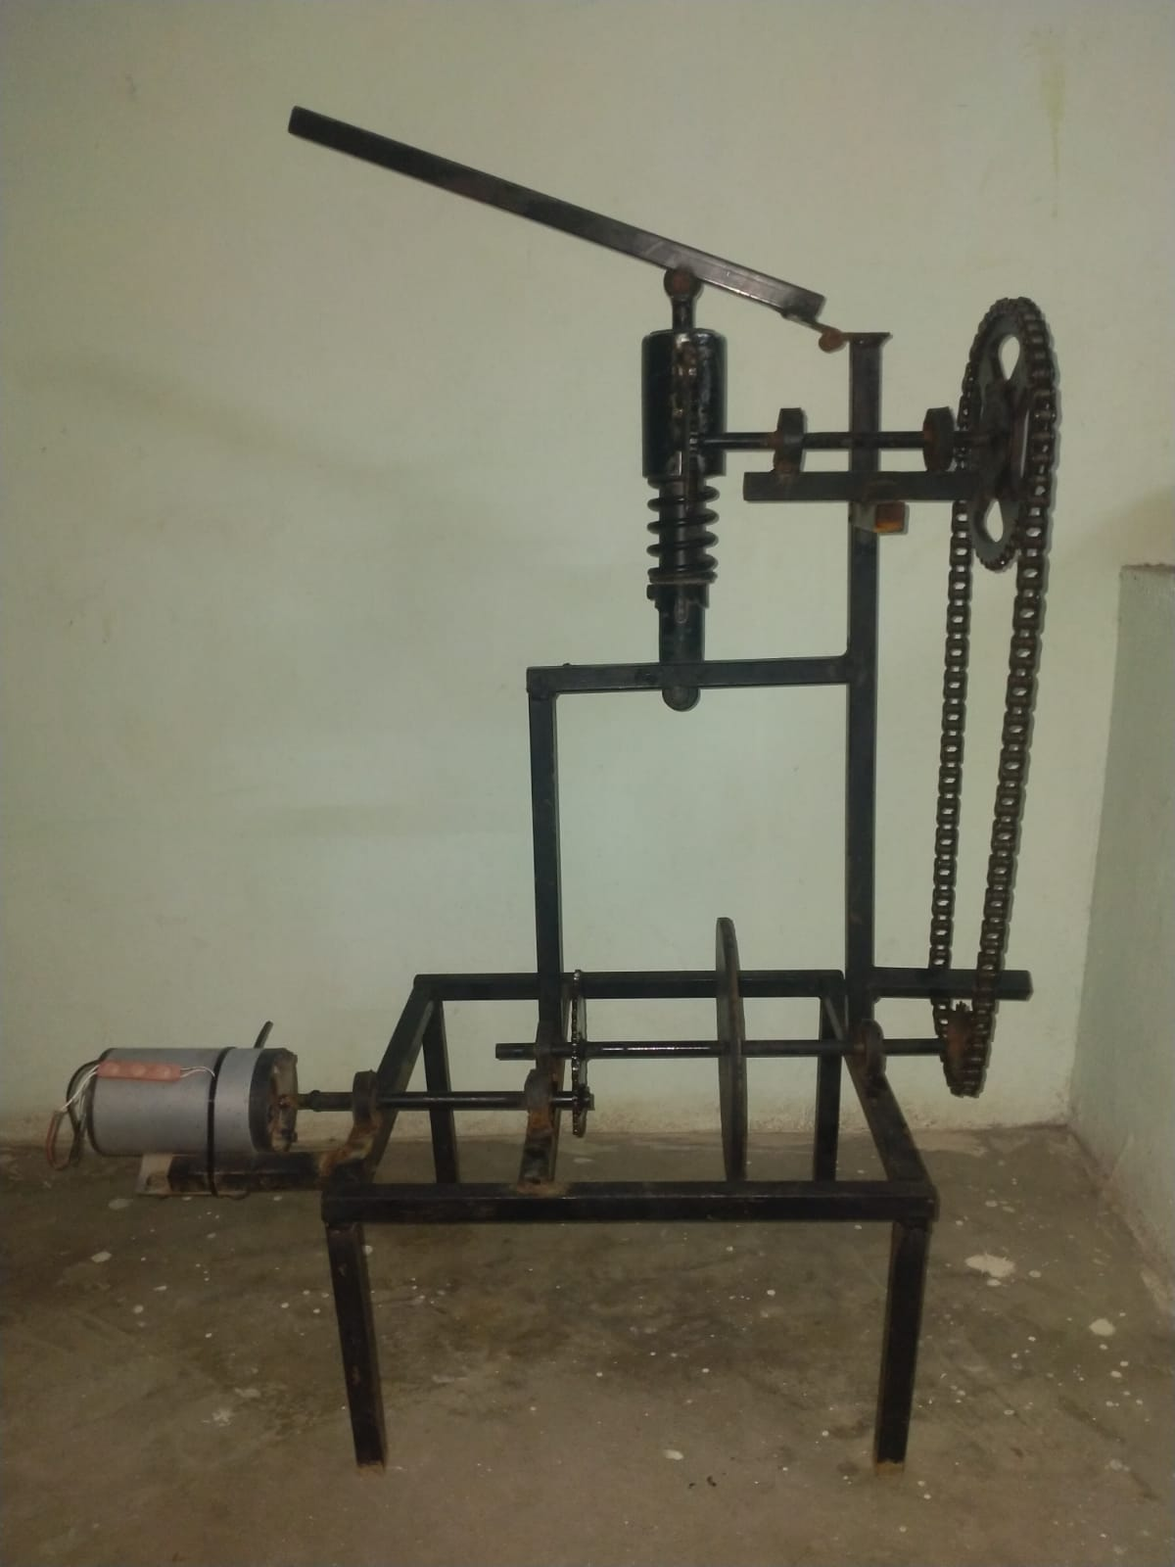

**CHAPTER 8**

**CONCLUSION AND REFERENCE**

**CONCLUSION**

##### Conventionally, the vibration energy of vehicle suspension is dissipated as heat by shock absorber, which wastes a considerable number of resources.

##### Power Generating Shock Absorber brings hope for recycling the wasted energy. All types of Power Generating Shock Absorber, especially electromagnetic suspension, and their properties are reviewed in this seminar.

##### From the perspective of comprehensive performance including vibration control ability, regenerative efficiency and application reliability, the configuration of hydraulic transmission and self-powered MR damper shows the best attraction.

##### With improvement of technology, Power Generating Shock Absorber may become one of promising trends of vehicle industry

REFERENCE

1. Arekar, M.P. and Shahade, S. (2015). Power Generating Shock Absorber. International Journal of Innovative Research in Science, Engineering and Technology, Volume 4, Issue 3: 169-178
2. International Journal of Engineering Technology, Management and Applied Sciences www.ijetmas.com March 2015, Volume 3 Issue 3, ISSN 2349-4476
3. International Journal of Pure and Applied Research in Engineering and Technology, Research Article Impact Factor: 0.621 ISSN: 2319-507X Swapnil Kamthe, IJPRET, 2014; Volume 2 (9): 169-178 IJPRET
4. Proceedings of the World Congress on Engineering 2013 Vol III, WCE 2013, July 3 - 5, 2013, London, U.K.
5. International Journal of Engineering Science and Innovative Technology (IJESIT) Volume 3, Issue 4, July 2014
6. Automobile Engineering Vol.1 by Dr. Kirpal Singh-(181- 182
7. S. Mirzaei, S.M. Saghaiannejad, V. Tahani and M. Moallem, “Electromagnetic shock absorber”, Department of Electrical and Computer Engineering, IEEE.
8. Bart L. J. Gysen, Jeroen L. G. Janssen, Johannes J. H. Paulides, Elena A. Lomonova, “Design aspects of an active electromagnetic suspension system for automotive applications”, IEEE transactions on industry applications, volume. 45, number 5
9. . Babak Ebrahimi, Mir Behrad Khamesee, M. Farid Golnaraghi, “Feasibility Study of an Electromagnetic Shock Absorber with Position Sensing Capability”, IEEE 2008, Page 2988-91.
10. Gupta A, Jendrzejczyk J A, Mulcahy T M and Hull J R, “Design of electromagnetic shock absorbers”, International Journal of Mechanics & Material Design, Volume 3, Number 3.
11. Goldner R B, Zerigian P and Hull J R, “A preliminary study of energy recovery in vehicles by using regenerative magnetic shock absorbers”, SAE Paper #2001-01-2071
12. Lei Zuo, Brian Scully, Jurgen Shestani and Yu Zhou, “Design and characterization of an electromagnetic energy harvester for vehicle suspensions”, Journal of Smart Materials and Structures, Volume 19, Number 4
13. . Pei-Sheng Zhang and Lei Zuo, “Energy harvesting, ride comfort, and road handling of regenerative vehicle suspensions”, ASME Journal of Vibration and Acoustics
14. Zhang Jin-qiu, PengZhi-zhao*, Zhang Lei, Zhang Yu,“A Review on Energy-Regenerative Suspension Systems for Vehicles”, WCE 2013, July 3 - 5, 2013, London, U.K
15. . Rahul Uttamrao Patil, Dr. S. S. Gawade,“Design and static magnetic analysis of electromagnetic regenerative shock absorber”
16. Zhongjie Li, Lei Zuo*, JianKuang, and George Luhrs ,Department of Mechanical Engineering, State University of New York at Stony Brook, Stony Brook, NY, 11794
17. Pedro Portela, JaaoSepulveda, Joao SenaEsteves, “Alternating current and Direct current Generator”, Sep 3, 2008
18. “Text book of Machine Design” by V.B. Bhandari 2012 Edition.